Translating Diversity
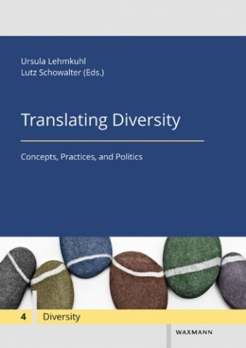

Translating Diversity, the fourth volume in the IRTG Diversity's publication series, invites the reader to participate in a discussion about how to conceptualize the mediation of difference in localities of diversity and transcultural spaces via the analytical lenses of ‘translation’ as a social practice. The contributions to the volume explore, discuss, and theorize ‘translation’ as a pre-institutionalized strategy of conflict resolution and conflict transformation as well as a driving force of cultural and social change and as a means of knowledge production. In addition to mistranslations and untranslatabilities, the authors analyze the politics of literary translation and translation as research-creation.

http://www.waxmann.com/buch3977

